Using normal query
Step 1:
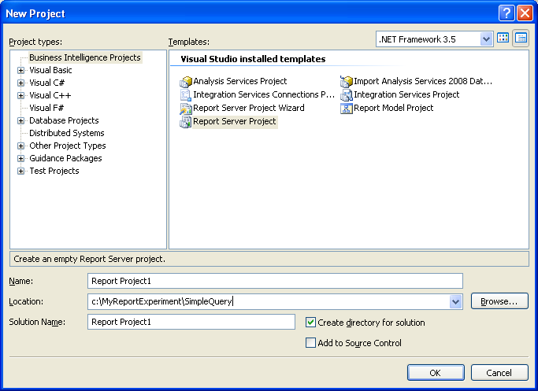
After clicking on OK button the below screen will appear
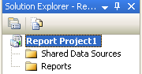

Step 2:
Click on the Shared Data Source - > New Data Source
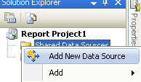
Step 3: Enter proper information in the Shared Data Source Properties
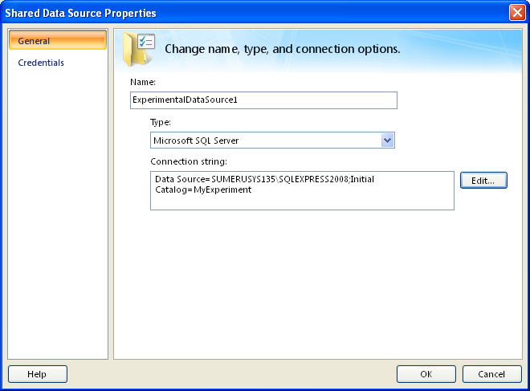

Note: The connection string will be available after clicking on the Edit button (As in below figure)
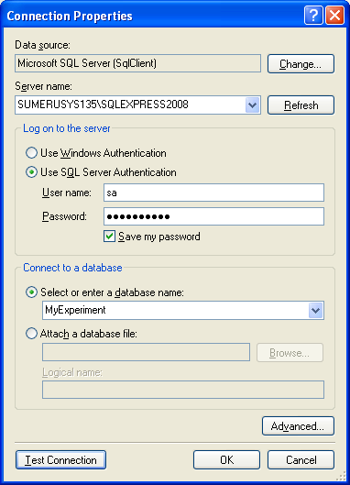

Step 4: After clicking on the OK button, the following screen will appear
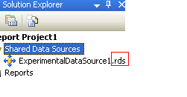
Note that the file name is .rds file

Step 5:
Next click on Reports - > Add New Report
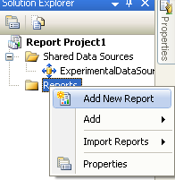

The report wizard will appear
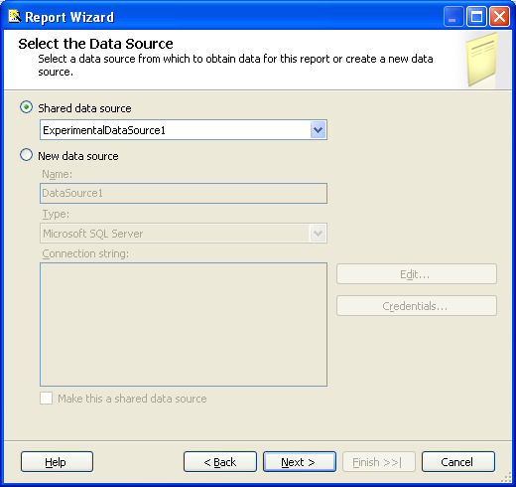
Click on Next
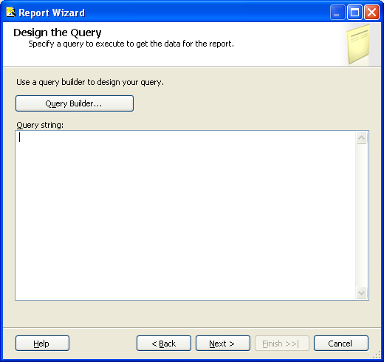
Click on Query Builder
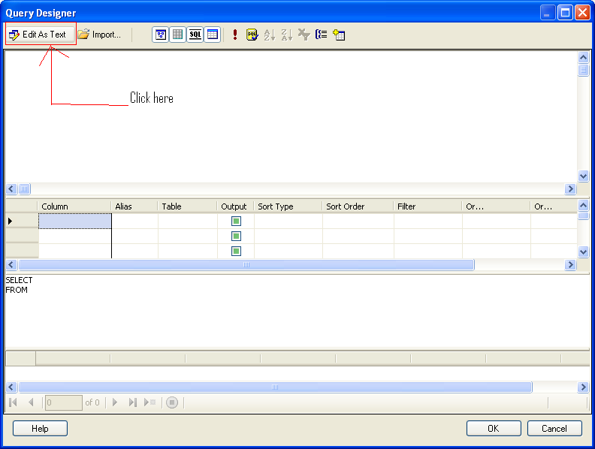

The below screen will appear. Note that 3 options are there in the table type
- Text (where we write the normal SQL query)
- Stored Procedure
- Direct table
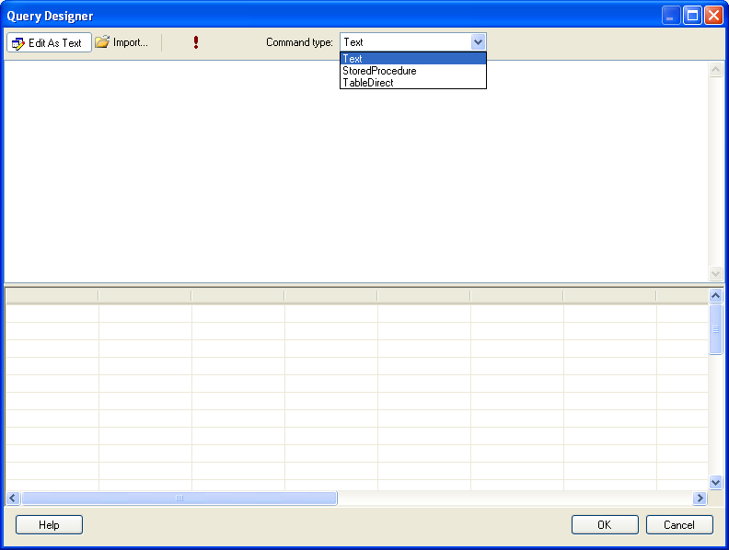
But in this example, I am interested only in the direct query; so I have chosen Text
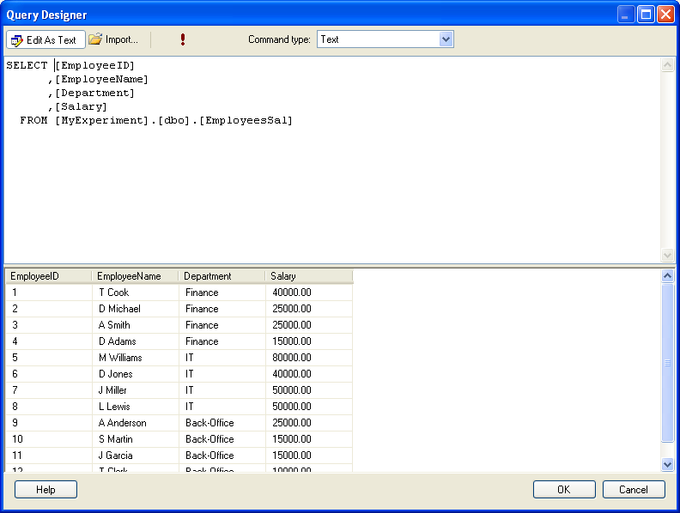
Click on the OK button.
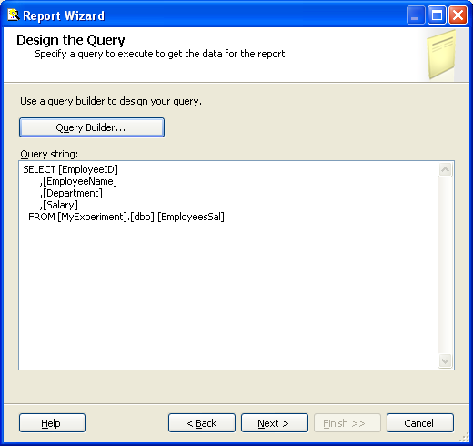
Click Next.(Choose Report Type)
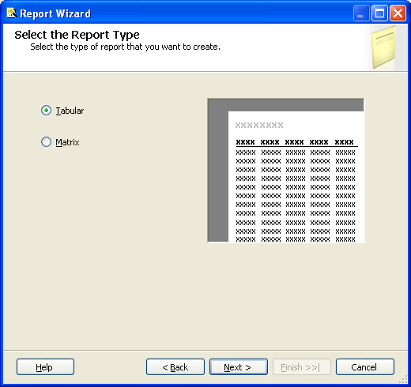

Click Next (Design Table)
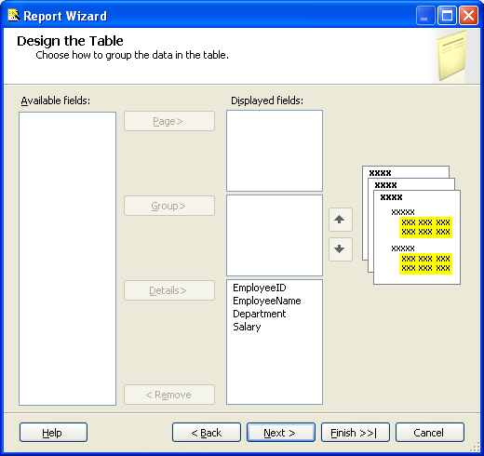
Click Next (Choose Table Style)
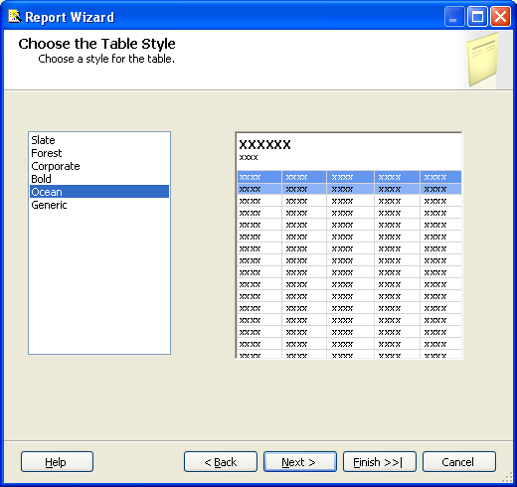

Click Next
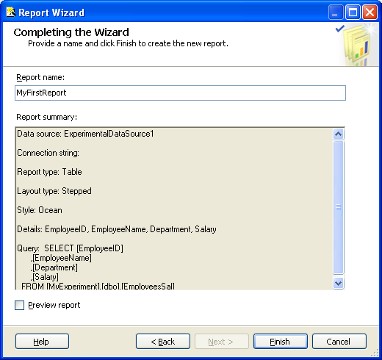
Click Finish.
Step 6:
Report created. The design view is
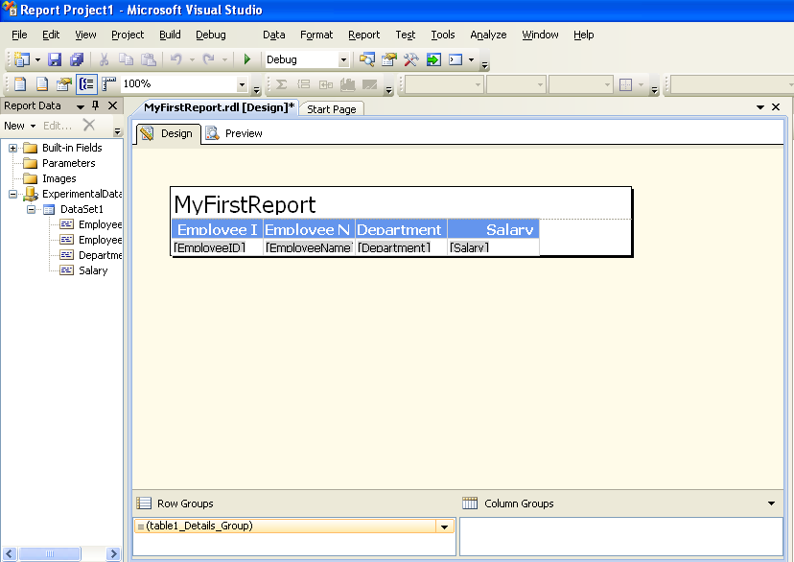
Click the Preview button.
